**AWS RDS SERVICE**

🡪Open RDS service

🡪Create a database on free tier and enable public access

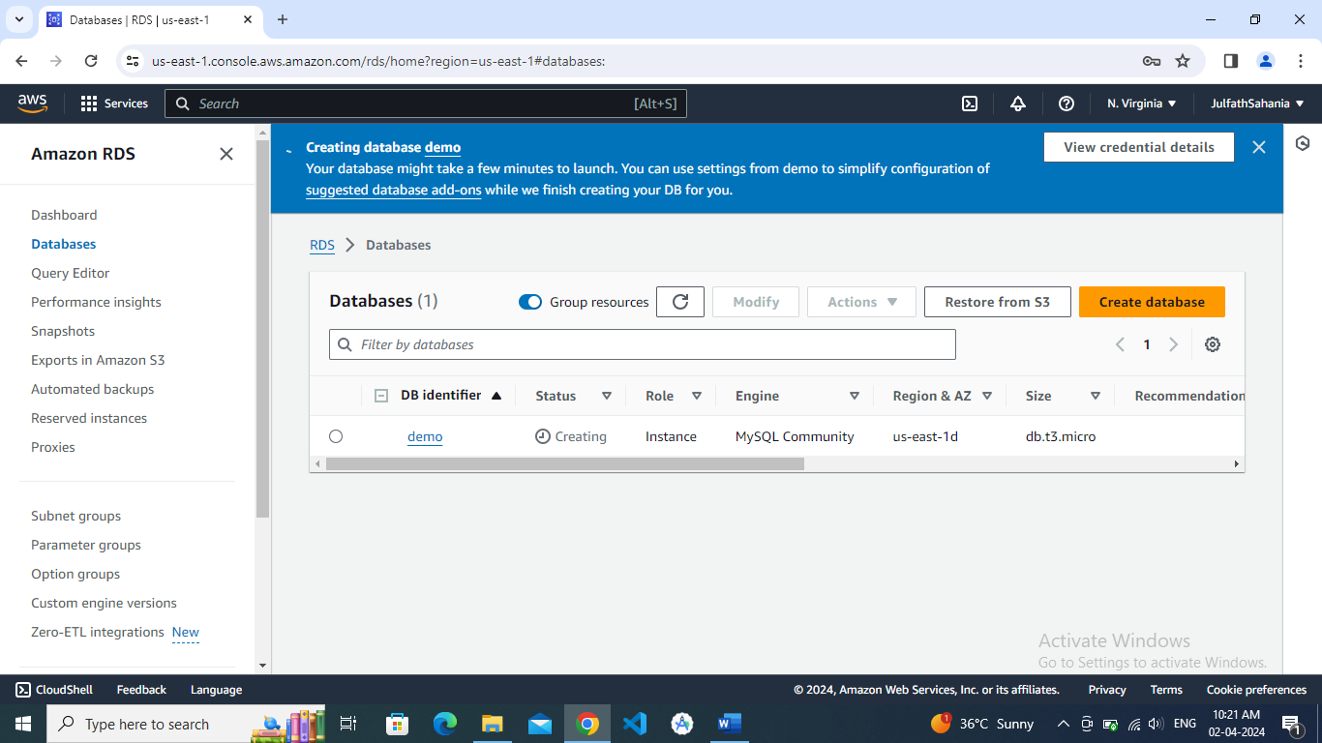

🡪copy the endpoint

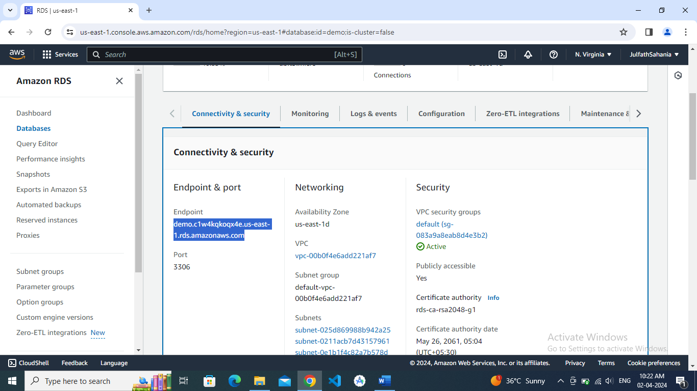

🡪Open security group edit inbound limits

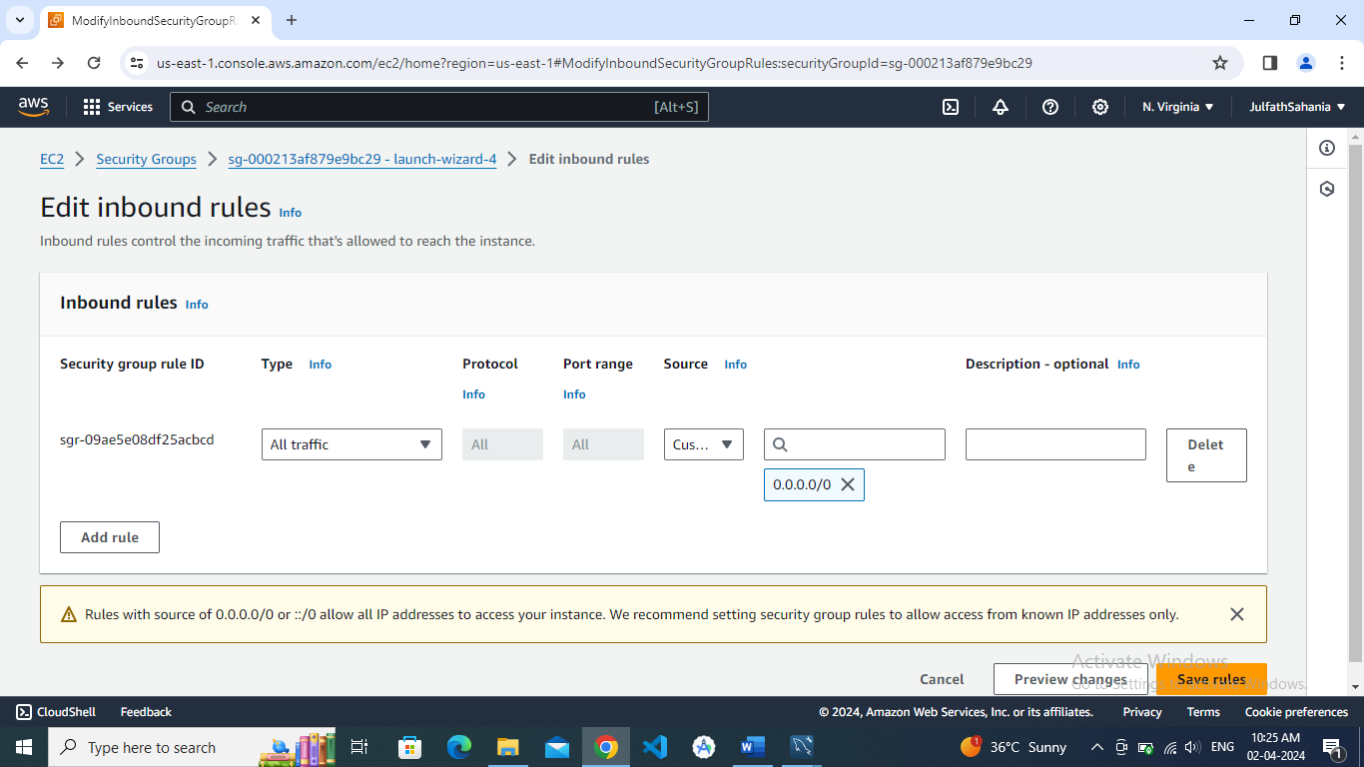

🡪open sql workbench and connect through endpoint create a table using sql code

